Advanced Programming Language

Assignment – 3

Chinmay Dorge

LCS2020022

Q1) Create a student class that contains three variables (name, roll number and phone number) and two methods for taking the inputs and display the results of those filed. Next class teacher and staff inherit the student class. The teach class contains another two variables (name and area of teaching) and two methods for taking the inputs and display the results of those filed. The staff class contains another two variables (name and work) and two methods for taking the inputs and display the results of those filed. Further, teacher class contains three further classes, namely science, arts and commerce and each of the class contain a variable number of student and further contains two methods for taking the inputs and display the results of this filed.

Code: Student.java

import java.util.Scanner;  
public class Student{  
 Scanner sc = new Scanner(System.in);  
 protected String name;  
 private int rollNumber;  
 private long mobileNumber;  
  
  
 public void takeInput(){  
 System.out.print("Enter Student's name: ");  
 name = sc.nextLine();  
 System.out.print("Enter Student's roll number: ");  
 rollNumber = sc.nextInt();  
 System.out.print("Enter Student's mobile number: ");  
 mobileNumber = sc.nextLong();  
 }  
  
 public void displayData(){  
 System.out.println("Student's name: " + name);  
 System.out.println("Student's roll number: " + rollNumber);  
 System.out.println("Student's mobile number: " + mobileNumber);  
 }  
  
}

Staff.java

import java.util.Scanner;  
public class Staff extends Student{  
 Scanner sc = new Scanner(System.in);  
 private String work;  
  
 public void takeInput(){  
 System.out.print("Enter Staff's name: ");  
 name = sc.nextLine();  
 System.out.print("Enter Staff's work: ");  
 work = sc.nextLine();  
 }  
 public void displayData(){  
 System.out.println("Staff's name: " + name);  
 System.out.println("Staff's work: " + work);  
 }  
}

Teacher.java

import java.util.Scanner;  
public class Teacher extends Student{  
 Scanner sc = new Scanner(System.in);  
 private String areaOfTeaching;  
  
 public void takeInput(){  
 System.out.print("Enter Teacher's name: ");  
 name = sc.nextLine();  
 System.out.print("Enter Teacher's area of teaching: ");  
 areaOfTeaching = sc.nextLine();  
 }  
  
 public void displayData(){  
 System.out.println("Teacher's name " + name);  
 System.out.println("Teacher's area of teaching " + areaOfTeaching);  
 }  
  
 public class Science{  
 private int numberOfStudents;  
 void takeInput(){  
 System.out.println("Enter number of students for Science stream: ");  
 numberOfStudents = sc.nextInt();  
 }  
 void displayData(){  
 System.out.println("Number of students for Science = " + numberOfStudents);  
 }  
 }  
  
 public class Arts{  
 private int numberOfStudents;  
 void takeInput(){  
 System.out.println("Enter number of students for Arts stream: ");  
 numberOfStudents = sc.nextInt();  
 }  
 void displayData(){  
 System.out.println("Number of students for Arts = " + numberOfStudents);  
 }  
 }  
  
 public class Commerce{  
 private int numberOfStudents;  
 void takeInput(){  
 System.out.println("Enter number of students for Commerce stream: ");  
 numberOfStudents = sc.nextInt();  
 }  
 void displayData(){  
 System.out.println("Number of students for Commerce = " + numberOfStudents);  
 }  
 }  
}

Q1.java

public class Q1 {  
 public static void main(String[] arg){  
 Student s1 = new Student();  
 s1.takeInput();  
 s1.displayData();  
 System.out.println();  
  
 Student s2 = new Student();  
 s2.takeInput();  
 s2.displayData();  
 System.out.println();  
  
 Teacher t1 = new Teacher();  
 t1.takeInput();  
 t1.displayData();  
 System.out.println();  
  
 Teacher t2 = new Teacher();  
 t2.takeInput();  
 t2.displayData();  
 System.out.println();  
  
 Teacher.Science sci = t1.new Science();  
 sci.takeInput();  
 sci.displayData();  
  
 Teacher.Commerce com = t1.new Commerce();  
 com.takeInput();  
 com.displayData();  
  
 Teacher.Arts art = t2.new Arts();  
 art.takeInput();  
 art.displayData();  
  
 Staff st1 = new Staff();  
 st1.takeInput();  
 st1.displayData();  
 System.out.println();  
  
 }  
}

Output:

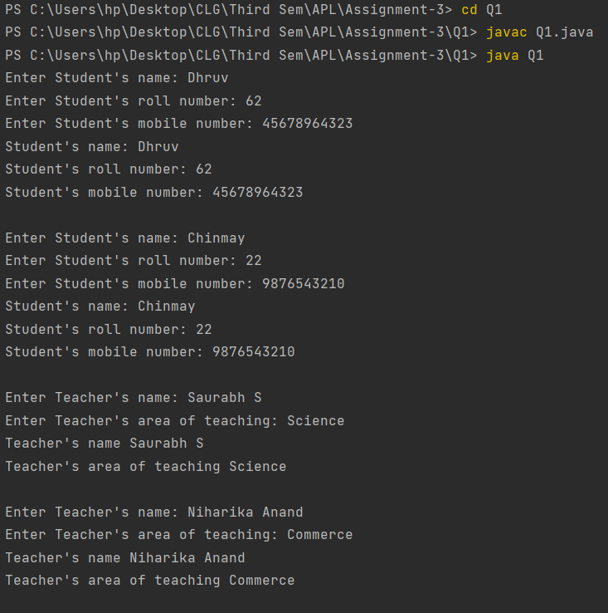

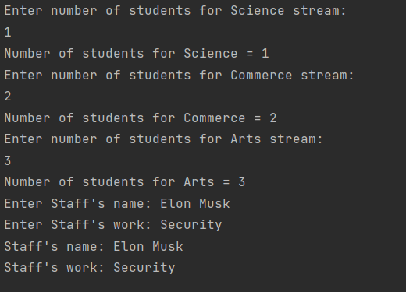

Q2) Create a java class namely arithmetic which contains four abstract methods namely addition, subtraction, multiplication and division that perform arithmetic operation by taking two numbers as inputs. Further, write four non-abstract classes that defines the functionality of the above-mentioned operations and display the results of those functions by creating another main class.

Code: arithmetic.java

abstract class arithmeticOperations{  
 abstract public double addition(double a ,double b);  
 abstract public double subtraction(double a ,double b);  
 abstract public double multiplication(double a ,double b);  
 abstract public double division(double a ,double b);  
}  
public class arithmetic extends arithmeticOperations{  
 public double addition(double a , double b){  
 return a+b;  
 }  
 public double subtraction(double a , double b){  
 return a-b;  
 }  
 public double multiplication(double a , double b){  
 return a\*b;  
 }  
 public double division(double a , double b){  
 return a/b;  
 }  
}

main.java

import java.util.Scanner;  
public class main {  
 public static void main(String[] arg){  
 Scanner sc = new Scanner(System.in);  
 System.out.print("Enter two numbers: ");  
 double a = sc.nextDouble();  
 double b = sc.nextDouble();  
  
 arithmetic ans = new arithmetic();  
 System.out.println("Addition = " + ans.addition(a,b));  
 System.out.println("Subtraction = " + ans.subtraction(a,b));  
 System.out.println("Multiplication = " + ans.multiplication(a,b));  
 System.out.println("Division = " + ans.division(a,b));  
 }  
}

Output:

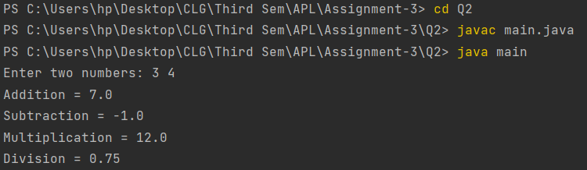

Q3) Write a specific scenario and then write a java program on that scenario like Question 1 and 2 that represent multiple inheritance can possible to implement using interface. Similarly, write a specific scenario and then write a java program on that scenario like Question 1 and 2 that represent interface extends another interface instead of implements. (Do not use the examples which have been discussed in the lectures).

1. A scenario where multiple inheritance can be possible to implement using interface. A remote toy car is both battery operated and remote controlled. So, it will contain properties of both the classes and inherit their properties via multiple inheritance.

Code: part1.java

interface batteryOperatedToy{  
 void checkBattery();  
 void repairBattery();  
}  
  
interface remoteOperatedToys{  
 void checkRemote();  
 void repairRemote();  
}  
  
class toyCar implements batteryOperatedToy , remoteOperatedToys {  
 toyCar(){  
 System.out.println("Toy car has been created");  
 }  
  
 @java.lang.Override  
 public void checkBattery() {  
 System.out.println("Checking battery...");  
 System.out.println();  
 }  
  
 @java.lang.Override  
 public void repairBattery(){  
 System.out.println("Repairing battery...");  
 System.out.println("...Successfully repaired");  
 System.out.println();  
 }  
  
 @java.lang.Override  
 public void checkRemote(){  
 System.out.println("Checking remote...");  
 System.out.println();  
 }  
  
 @java.lang.Override  
 public void repairRemote() {  
 System.out.println("Repairing remote...");  
 System.out.println("...Successfully repaired");  
 System.out.println();  
 }  
}  
  
public class part1 {  
 public static void main(String[] args){  
 toyCar obj = new toyCar();  
 obj.checkBattery();  
 obj.repairBattery();  
 obj.checkRemote();  
 obj.repairRemote();  
 }  
}

Output:

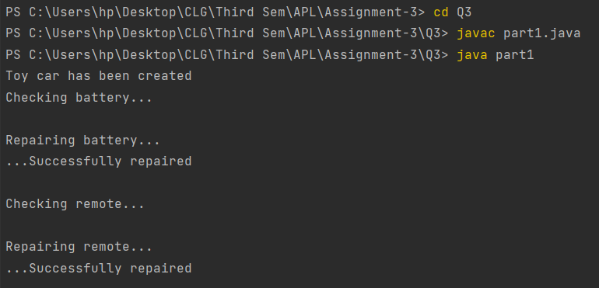

1. A scenario that represents interface extends another interface. A smartphone can perform the same functions as a normal mobile. So smartPhone interface extends mobile interface instead of implementing.

part2.java

interface mobile{  
 void makeCall();  
 void checkTime();  
}  
  
interface smartPhone extends mobile{  
 void playGames();  
 void watchMovie();  
}  
  
class myPhone implements smartPhone{  
  
 @java.lang.Override  
 public void makeCall() {  
 System.out.println("Making a call ...");  
 System.out.println();  
 }  
  
 @java.lang.Override  
 public void checkTime() {  
 System.out.println("Checking Time ...");  
 System.out.println();  
 }  
  
 @java.lang.Override  
 public void playGames() {  
 System.out.println("Playing games ...");  
 System.out.println();  
 }  
  
 @java.lang.Override  
 public void watchMovie() {  
 System.out.println("Playing movie ...");  
 System.out.println();  
 }  
}  
  
public class part2{  
 public static void main(String[] args){  
 myPhone obj = new myPhone();  
 obj.makeCall();  
 obj.checkTime();  
 obj.playGames();  
 obj.watchMovie();  
  
 }  
}

Output:

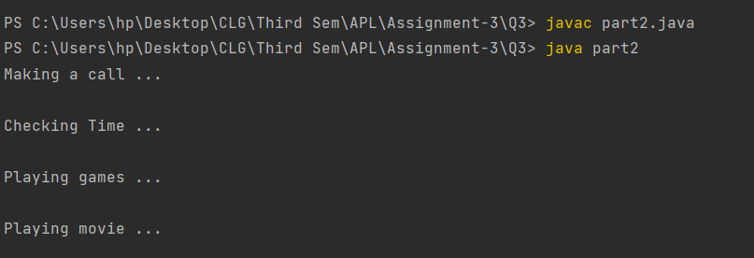

Q4) Write a recursive definition in java that converts binary number to decimal number.

Code: Main.java

import java.util.Scanner;  
public class Main {  
 static long binaryToDecimal(String bin , int i){  
 int n = bin.length();  
 if (i == n-1)  
 return bin.charAt(i) - '0';  
  
 return ((bin.charAt(i) - '0') << (n-i-1)) +  
 binaryToDecimal(bin, i+1);  
 }  
  
 public static void main(String[] args){  
 Scanner sc = new Scanner(System.in);  
 System.out.print("Enter binary number: ");  
 String input = sc.nextLine();  
 System.out.println("Decimal = " + binaryToDecimal(input,0));  
 }  
}

Output:

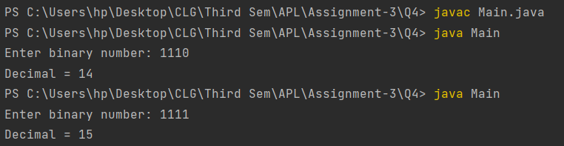

Q5) Write a specific scenario and then write a java program on that scenario like Question 1 and 2 that contains both method overloading and method overriding in the same program.

A scenario that contains both method overloading and method overriding in the same program. Football class inherits Sport class and play() function has been both overloaded and overridden.

Code: Sport.java

public class Sport{  
 public void play(){  
 System.out.println("Playing sport");  
 }  
}

Football.java

public class Football extends Sport{  
 @java.lang.Override  
 public void play() {  
 System.out.println("Playing Football");  
 }  
  
 public void play(int a , int b){  
 System.out.println("Playing football with score " + a + " - " + b );  
 }  
}

Main.java

public class Main {  
 public static void main(String[] args){  
 Football f = new Football();  
 f.play(); // overriding  
 f.play(3,4); // overloading  
 }  
}

Output:

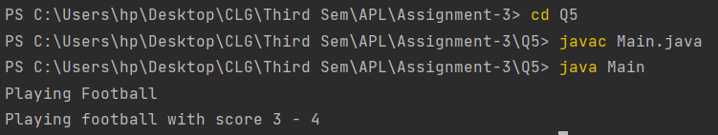

Note: The code has also been sent with the zip file and is available on GitHub. Link for the repository:

<https://github.com/Chinmay-Dorge/Advanced-Programming-Assignments>